The Rise of e-Sports

Chao Zhang, Adam Weston, Nick Quintela, Brandon Smith

Mohawk College

Institute of Arts and Technology

Lois Wright

Introduction

Everyone knows that sporting events such as football, hockey and basketball are amongst the greatest entertainment available for viewing. However, these events are not for all demographics in today’s society. With the progression of growing technology and the internet, competitive gaming events have blossomed into a massive community with millions of viewers online and thousands of live audience members. These collective events are known as electronic sports (e-Sports). This report will introduce three major LAN tournaments in e-Sports events, proving that they are worthy to be categorized as competitive sporting entertainment just like physical sports. It will also outline the history of these LAN events and how it has grown over the years, gaining major popularity amongst the gaming community. All of the members of this group actively follow the e-Sports scene so the information gathered is from our personal experiences and internet articles.

Main Heading

Evolution Championship Series

Evo or Evolution Championship Series is an annual electronic Sporting event that was originally made for arcade style fighting games. The original name of the tournament started off as “Battle by the Bay”, which was changed to the name used currently, “Evo” in 2002. The tournament is well known in the fighting game community, which players or even spectators will travel from all around the world to be at, most commonly from Japan. Evo was founded in Sunnyvale, California in 1996 by Tom Cannon. The tournament originally started playing Super Street Fighter II Turbo and Street Fighter Alpha 2. The tournament was later moved to Las Vegas where it is now hosted annually. Originally Evo would use Arcade machines in their tournaments, in 2004 the games were moved over to their console versions.

Evo among all the different e-Sports types is growing at a rapid rate. Some types are growing faster than others but Evo has become the largest and longest-running fighting game event in the world. Compared to the popularity of Evo when it first started it has grown dramatically. In 1998 the Evo Championship Series started out as a small gathering of friends in an arcade. Since 2009 Evo has exploded in popularity, year after year breaking their previously set records. With only 2400 competitors the 2011 Evo broke the record for the most viewed event in history with over 2 million unique viewers from all around the world. The viewer’s consumed over 1.9 million hours of video content with an average of 55 minutes per person. The finals became so popular that the finalists became four of the top 10 trending topics on twitter. Evo 2011 wasn’t the only event to break records, in 2013 Evo broke the record for the most competitors in a single event in competitive gaming and e-Sports history with exactly 3,538 competitors. That’s just the competitors, Evo 2013 as a grand total of 6,097 entries across 51 countries. Over the 3 day event over 30,485 matches were played. More stats that were counted for this even were; Miles travelled which totaled to an amazing 6,636,661 which totals to 266 trips around the earth.

As these Evo events continue more and more people are becoming a part of that community so Evo has now started raising money for charities, making a total of $225,744 in 2013. As just one of the many different e-Sports events these statistics are absolutely amazing, and show just how much the e-Sports community has grown over the years.

Major League Gaming

A few years ago, if you were to ask someone if they knew what Major League Gaming was, they would most likely be unable to tell you, let alone believe you when you told them how popular it was becoming. Yet here we are today riding the wave of one of the biggest explosions in gaming history. The e-Sports scene is one that has managed to stay quite underground for a long time. With large tournaments dating back to even the early 2000’s, e-Sports has been silently making its way to the forefront of popularity, waiting for the opportunity to seize the crown of mainstream success. Today, there is an ever expanding market for e-Sports viewing, spanning a variety of different games that each bring a different following from around the world. Perhaps one of the biggest organizations right now is MLG – or Major League Gaming. With small beginnings in 2002, MLG has made a point of being the medium for whatever game is most popular in the e-Sports scene. This has propelled them into amazing success in this industry, having played host to a significant amount of tournaments from some of the most competitive games to date: Super Smash Bros. Melee, Halo 2, Halo 3, Call of Duty, World of Warcraft, Starcraft 2, League of Legends and more.

What is most interesting about e-Sports is the sudden spike in popularity that came about from streaming services. The internet is something that they knew everybody has, so rather than aim for Television as their method of delivery, many companies including MLG opted for online streaming instead. A clever move indeed, by enabling their target demographic – guys in the 18-24 age bracket mostly – to simply tune in via their web browser, they opened the door for a much larger and more diverse audience. In fact, with the release of MLG.tv, the most recent modification to the MLG brand, they saw immense numbers in regards to viewing. In its beta testing stage, the site streamed more than 1.3 petabytes – over 1 million gigabytes – of content. MLG has been a forerunner in enabling their audience to take part in all the action of their events, consistently undergoing changes to their all-inclusive web hub in order to provide people with the best method of viewing for their favourite games. Despite previous ties to ESPN, they knew that e-Sports viewing needed to be taken into the more free market of the internet. It was an obvious move, and one to be followed by some of the other leaders in the industry, Riot Games – with their League of Legends Season 3 World Championship hosting a commendable 8.3 million viewers (more than 2013’s Stanley Cup per game viewership of 5.4 million) – Blizzard, known for hosting the Starcraft II World Champion Series offering up $1.6million in winnings across 13 events, and Twitch.tv – perhaps the biggest name in online streaming.

It isn’t hard to see why e-Sports has exploded in the manner it has. People have been playing competitive games for decades now, but now there is a refined medium for both rising to the challenge of competing, as well as taking part as a supporter and spectator. With the leading games always changing, MLG seeks to further the e-Sports scene by releasing new additions to their viewing experience in the form of MLG.tv and by continuing to host some of the best tournaments across North America. They are already up there competing with the big leagues having almost already surpassed some of the most popular sports leagues in America such as the NFL and NBA. What is next for e-Sports? Perhaps we’ll see a bigger emphasis on including the whole world in its success, with tournaments being hosted in other parts of the world in which games are prominent. Either way, it is without a doubt that e-Sports has made it in the world today, playing a significant role in the lives of millions of gaming fanatics.

League of Legends

The e-Sports scene is one that has undoubtedly experienced rapid growth in recent years. A number of great games have come along and gathered large fan bases which help attract a large audience to e-Sports. Some of the notable games in recent years are extremely competitive games ranging from the FPS to multiplayer online battle arenas. The largest titles have been Starcraft, Defense of the Ancients, Halo and Call of Duty. The largest title however, that has exploded upon the e-Sports scene in recent years is the multiplayer online battle arena (MOBA) game League of Legends. League of Legends entered the scene in 2009 and has experienced explosive growth in terms of players in 2012 and 2013.

In October of 2009, League of Legends had officially launched in North America and Europe. It quickly picked up a relatively small but dedicated fan base. The game’s potential was almost instantly recognized by the industry and had picked up a Readers’ Choice and a PC Gamers’ Choice award in December of that year. In 2010, League of Legends started Season 1 of its competitive season, which really set the precedent for multiplayer online battle arenas and established League of Legends in the e-Sports scene. League of Legends competitive seasons would end off with a tournament where the top teams in the world would face off and compete for prize money. Teams would literally pursue success in these tournaments as a full time endeavor, many of the players involved are pursuing League of Legends e-Sports as a career. With each of the consecutive seasons, the player base has grown and League of Legends has become the most popular game in the world. The number of tournament circuits for League of Legends has grown each year and there are now a vast number of venues for players to compete. The official tournaments run by Riot, the creators of League of Legends run tournaments leading up to the world finale at the end of the season where players could earn up to $50,000 in Season 1, and up to $1,000,000 in Season 2 and 3. These epic competitions hosted by riot have racked up hundreds of millions of views from fans world-wide and have revolutionized the e-Sports scene. The Season 1 World Championships in June 2011, held at Dreamhack in Sweden, featured over 1.6 million viewers who watched live streaming broadcast of the event, with a peak of over 210,000 simultaneous viewers in one semi-final match. The venue hosted 200 live audience members. Season 2 World Championships was held in downtown Los Angeles with the finals hosted in the gym of University of Southern California in October 2012. The tournament reached a peak of 1 million streaming viewers online simultaneously with 7000 live audience members. After the success of season 2, League of Legends exploded in popularity and became the most played game worldwide. Season 3 Championships tournament was held in the Staples Center in Los Angeles. This tournament was by far the biggest venue in e-Sports history. It reached a total of 32 million viewers with a peak of 8.5 million viewers simultaneously also held a live audience of 11000 members. Players world-wide are now looking to find their spot in the League of Legends e-Sports world.

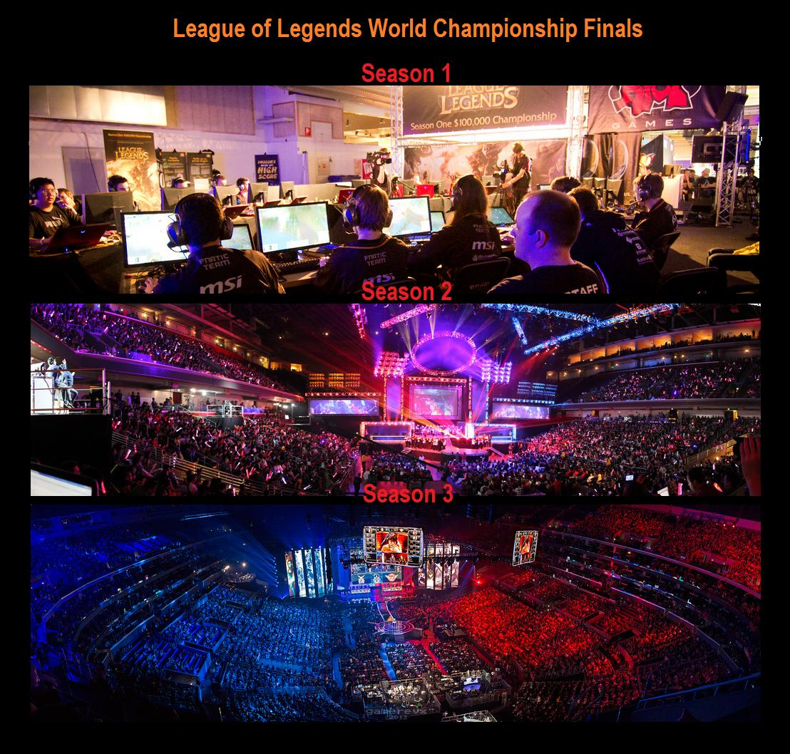

Conclusions

1. e-Sports is growing in popular due to the progression of technology and the internet

2. e-Sports is worth being categorized as competitive sports due to the millions of fans supporting it

3. e-Sports is still continuing to grow with the support of increasing sponsors it will continue to prosper in today’s society

References

Breslau, R. (2013). *EVO 2013 to draw record number of attendees*. [online] Retrieved from: http://www.ongamers.com/articles/evo-2013-to-draw-record-number-of-attendees/1100-41/ [Accessed: 23 Nov 2013].

Cannon, T. (2013). *Update: Smash is Back!! Changes to Evo 2013 Smash Schedule*. [online] Retrieved from: http://shoryuken.com/2013/07/09/changes-to-evo-2013-smash-schedule/ [Accessed: 23 Nov 2013].

Competitive.na.leagueoflegends.com (2013). *Season 2 World Championship | LoL - League of Legends*. [online] Retrieved from: http://competitive.na.leagueoflegends.com/season-2-world-championship [Accessed: 23 Nov 2013].

Crecente, B. (2013). *Fighting to Play: The History of the Longest Lived Fighting Game Tournament in the World*. [online] Retrieved from: http://kotaku.com/5054856/fighting-to-play-the-history-of-the-longest-lived-fighting-game-tournament-in-the-world [Accessed: 23 Nov 2013].

Eventhubs.com (2013). *EVO 2011 breaks online viewership records*. [online] Retrieved from: http://www.eventhubs.com/news/2011/aug/04/evo-2011-breaks-online-viewership-records/ [Accessed: 23 Nov 2013].

EVO Championship Series (2013). *Evo Tournament Format*. [online] Retrieved from: http://evo.shoryuken.com/evo-player-guide/evo-tournament-format/ [Accessed: 23 Nov 2013].

Gamespot.com (2013). *Blizzard, MLG, TwitchTV execs speak on rise of eSports*. [online] Retrieved from: http://www.gamespot.com/articles/blizzard-mlg-twitchtv-execs-speak-on-rise-of-esports/1100-6405233/ [Accessed: 23 Nov 2013].

IGN (2013). *The Rise of eSports in America - IGN*. [online] Retrieved from: http://ca.ign.com/articles/2013/07/25/the-rise-of-esports-in-america [Accessed: 23 Nov 2013].

Na.leagueoflegends.com (2013). *One World Championship, 32 million viewers | League of Legends*. [online] Retrieved from: http://na.leagueoflegends.com/en/news/esports/esports-editorial/one-world-championship-32-million-viewers [Accessed: 23 Nov 2013].

Walbridge, M. (2013). *In-Depth: Inside The EVO 2009 Fighting Game Championships*. [online] Retrieved from: http://www.gamasutra.com/php-bin/news_index.php?story=24520 [Accessed: 23 Nov 2013].

Winkle, D. (2013). *Major League Gaming, PlayStation 4, and the Rise of Online Gaming Spectatorship*. [online] Retrieved from: http://www.geekosystem.com/online-gaming-spectatorship/ [Accessed: 23 Nov 2013].